**Task Description:**

Launch Jenkins and explore creating projects and users.

**Step 1: Launch an instance in EC2 (Amazon linux 2023)**

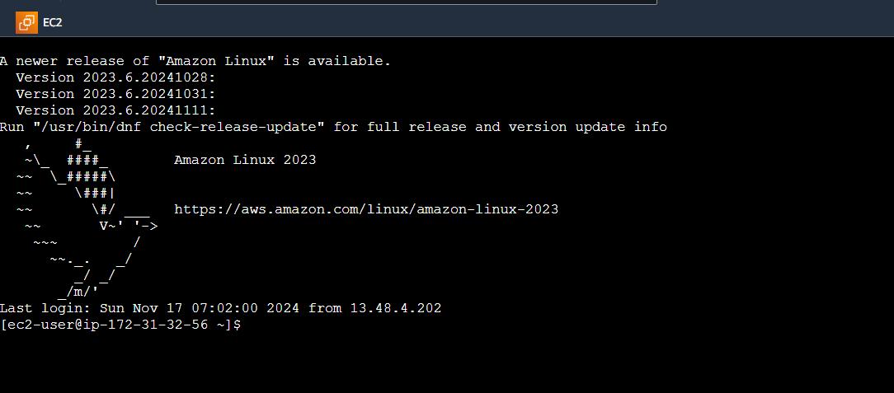

**Step 2: Downloading Jenkins**

*~ sudo yum update –y*

*~ sudo wget -O /etc/yum.repos.d/jenkins.repo \ https://pkg.jenkins.io/redhat-stable/jenkins.repo*

*~ sudo rpm --import https://pkg.jenkins.io/redhat-stable/jenkins.io-2023.key*

*~ sudo yum upgrade*

**Step 3: Install Java and Jenkins**

*~ sudo dnf install java-17-amazon-corretto -y*

*~ sudo yum install jenkins -y*

**Step 4: Enable and Start Jenkins as a Service**

~ sudo systemctl enable Jenkins

~ sudo systemctl start jenkins

~ sudo systemctl status jenkins

**Step 5: Configuring Jenkins**

Connect to **http://13.59.154.163:8080** in our browser

~sudo cat /var/lib/jenkins/secrets/initialAdminPassword

**Step 6: Create admin Users in Jenkins**

**Instance Configuration**

**Jenkins is ready to use now**

**Step 7: Create Projects**

*Create a project name “Guvi_Project” with Pipeline project and configure it with github and build test*

**Step 8: Create Users**

*Go to* ***Manage Jenkins*** *>* ***Manage Users*** *>* ***Create User to add users*** *with roles and permissions*

